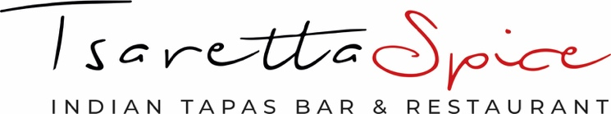

CHRISTMAS FEAST MENU 1

2 courses at £32.50 per head or 3 courses at £38.50 per head
(The appetiser is included in both options)

Papadums
Served with our homemade chutneys (D,V)

STARTERS
Asparagus Makai Croquettes
Spiced corn kernels with asparagus, ginger and chilli served with tomato chutney (VE)
Crispy Chilli Aubergine
Sliced aubergine cooked with fresh chilli until the skin is crisp to the bite (VE)
Achari Murgh Tikka
Tender chicken pieces marinated with pickling spices and chargrilled in the tandoor (D)
Hyderabadi Lamb Chops
Marinated in sweet red chilli, coriander, ginger, nutmeg and honey (D)

MAINS
Nellore Chicken Curry
Chicken fillet cooked with tomatoes, poppy seeds and curry leaves
Laal Maas
Slowed cooked lamb in Kashmiri chilli, black cardamon and brown onion
Pumpkin Paneer
Indian cheese cooked in pumpkin and onion sauce (D,V)
Katrika Masala
Spiced aubergine cooked in a delicate masala sauce (VE)

Served with
Thoran
Red cabbage, mangetout, mustard seed and coconut (V)
Pilau Rice
Peshwari Naan, Truffle Naan (D,E,G,N)

DESSERT
Mince Pie Brownie
Rich chocolate, chopped fruit and mixed spices served with Madagascan vanilla ice cream (D)

Spice Rating: Medium Spicy

Allergens: D - Dairy, E - Egg, F - Fish, G - Gluten, N - Nuts, V - Vegetarian, VE - Vegan
Menu items may contain or come into contact with dairy, egg, fish, gluten, nuts and other allergens
Please ask a member of staff if you require more information.

